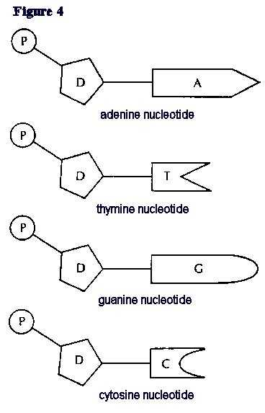

DNA Bases
DNA is made up of a twisted double strand (double helix) of special chemicals called nitrogen bases. The sequence these bases come in stores genetic information.
Adenine bases (A) always join to __________( ) bases.
Thymine bases (T) always join to ________( ) bases.
Cytosine bases always join to ____________( ) bases.
Guanine bases always join to _____________ ( ) bases.
This is called complimentary base pairing.
Instructions.
LOOK AT SHEETS 2, 3 AND 4
- Colour all of the Adenines(A) red.
- Colour all of the thymines(T) blue.
- Colour all of the cytosines(C) green.
- Colour all of the Guanines(G)orange.
- Cut out the Bases on JUST sheet 2 and 3.
- Match the bases to the strand on sheet 4.
- Glue them in place ON SHEET 4.

